LAB NDD

Steps for generating LAB NND

- Pre-conditions:
- Existing investigation
- At least one associated lab to the existing investigation

- The first step is creating a notification from the investigation.

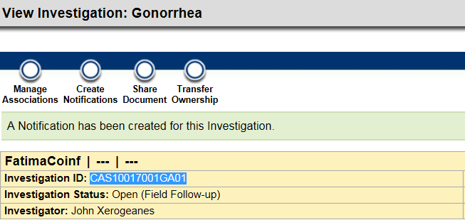

- After the notification has been created, a new entry is added to the Notification table:

  - select * from notification where notification_uid in
(select source_act_uid from act_relationship where target_act_uid in
(select public_health_case_uid from public_health_case where local_id = 'CAS10017001GA01')
and type_cd = 'Notification')

- Run the MsgOutProcessor batch process:

  - ..\wildfly-10.0.0.Final\nedssdomain\Nedss\BatchFiles> MsgOutProcessor

- Java code starts. It does some validations first:
  - Check there’s at least 1 lab associated to the investigation.
  - Check if the investigation is not one of the following types:
    - Arbo_Case_Map_v1.0
    - Gen_Case_Map_v1.0
    - TB_Case_Map_v2.0
    - Var_Case_Map_v2.0
    - MAL_Case_Map_v1.0

- If previous validations are successful, then data coming from the nnd_metadata and nbs_ui_metadata tables is read where the investigation_form_cd = LAB_EVENT.

- The stored procedure addLabEventData_sp is called to create flat data.

- Flat lab data is added to the LAB_EVENT table.

  - If there are already records in LAB_EVENT table for the same observation_uid, they are moved to the LAB_EVENT_HIST table.
  - The new records are added to the LAB_EVENT table.

- Run the following query to see the new records added to LAB_EVENT table:

select * from lab_event where investigation_uid in (select public_health_case_uid from public_health_case where local_id = 'CAS10017001GA01')

- Once we have the flat data in the LAB_EVENT table and the metadata, caseNotificationDTs are created for each of the elements of labs, results, susceptibilities, and susceptibility results.

- After doing necessary changes to the data (like lookups), the intermediary message is built and added to the message_payload column in a new record in the cn_transportq_out table:

select * from cn_transportq_out where public_health_case_local_id = 'CAS10017001GA01' order by 1 desc

- The MsgOutProcessor has finished.

- Rhapsody takes the intermediary message from the cn_transportq_out, it makes the necessary changes and creates the HL7 message:

select distinct b.recordid, convert(varchar(max), convert(varbinary(max), payloadcontent)) as HL7,
a.notification_Local_ID,
b.messageid,
a.public_health_case_local_id
from [NBS_ODSE].[dbo].[CN_transportq_out] a
inner join [NBS_MSGOUTE].[dbo].[transportq_out] b on b.messageid = a.notification_local_id
where a.public_health_case_local_id = 'CAS10017001GA01' order by recordId desc

Finding errors

The following workflow can be helpful in order to figure out where the issue is:
- If there’s something wrong in the HL7:
  - If it is correct in the Intermediary message: Rhapsody issue.
  - If it is not correct in the Intermediary message:
    - If it is correct in the Lab_event table:
      - If it is correct in the metadata table: Java issue
      - If it is not correct in the metadata table: nnd_metadata or nbs_ui_metadata table.
    - If it is not correct in the Lab_event table: Stored procedure issue.

Rules

Some rules were applied to the stored procedure. They can be found below:
- If Result Status (lab or result) is NULL, it is replaced by F.

- If Result Status (susceptibility) is NULL or A, it is replaced by F.

- If effective_from_time = NULL, it is replaced by rpt_to_state_time. If by rpt_to_state_time is also NULL, it is replaced by add_time.

- If activity_to_time = NULL, it is replaces by status_time. If status_time is also NULL, it is replaced by rpt_to_state_time.

- Result status codes are changed to different codes based on the following table:
select ELR_XREF.to_code, ELR_XREF.from_code from NBS_SRTE.dbo.ELR_XREF where to_code_set_nm = 'ACT_OBJ_ST'

